**Hatha Yoga Teacher training Day 1, Friday January 12** , 13.30-18.30

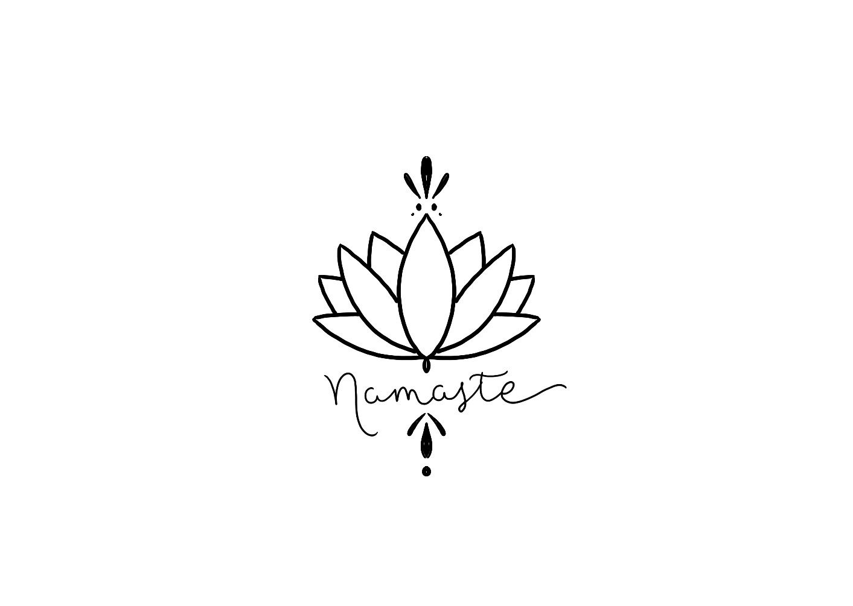

My soul honours your soul.  
I honour the love, light, beauty, truth and kindness within you  
because it is also within me.  
In sharing these things, there is no difference between us.  
We are the same. We are one.

**Opening ceremony**

All introduce themselves with name and heartfelt desire to commit to the teacher training.

A few desires and reasons of the big Why..

* Developing a new kind of quality
* Self healing
* Spiritual journey
* Deepen the practise of yoga
* Coming out of the mind and into the body
* Learning about becoming more present in the moment
* Manifesting a heartfelt desire

Wishes of Margriet en Lahma

* That we’re coming Home where the place for harmony is in the true self
* That we will learn about respect towards ourselves and others and everyones unique qualities
* Exploring potentials and nono-violence state
* Respecting limitations and see them as a guidance and how to expose our vulnerability
* Open the heart & body and feeling joy

**Practical Info**

* We have started… welcome!
* Practical: if you need food, bring it.
* Please be silent in the shala as it is sacred ground. If yo want to talk, please do that in the reception and hall.
* One person makes comprehensible notes per day of the weekend and distributes them within one week. This makes the ‘report’ of the training; what is shared, said and taught will be in the notes. At the end of the training, collect them all and make them into your personalised TT workbook. Make notes in English and share them within one week, to keep the information fresh and give all students possibility to prepare for next weekend.
* One person makes notes, the other is the karma yogi – you switch after one day. You are making tea, you clean up if needed, see if the candles are still burning etc.
* The karma yogini that makes notes also shares information about the day with students that wer not in class. This is a humble service and makes you aware that we all have to take care and are responsible of everything.   
  Before enlightenment, we do the dishes: after enlightenment, we do the dishes.
* Everything said int he training stays within the walls of the studio. Share only how you felt about something, not what someone else did or say.
* Important thing about pause. Pauzes are essential and individual. Everybody decides for themselves how to use the break. Respect what the other person needs. You can take a walk, we feel also free to prepare our next subject, you can eat/drink/ make notes or take a long shavasana .
* Always bring your Yoga-Sutra’s book
* During the practise, we will make adjustments.
* Next to the TT classes, you can also practice with your peers (at home).
* For the Teachertraining period, attend at least two Yoga classes a week - preferably at Yogaspot (Hatha, Hatha Flow or Vinyasa) en do a self practice (2 x per week). That starts with 15 minutes (just the things we practiced) and gradually becomes more.
* Keep a diary of your practice. This is your personal diary. You can make notes of your series, of what you felt, what the practice did to you.
* Create a group to practice your teacher skills on. Can be your friend, mother, child, partner, everybody. By practicing on somebody else (not being a yogi) you learn a lot about choice of words / cueing.
* There is a speciall class card for HYTT students for €69.If you want one, fill in the [form](https://forms.gle/7ZupHNAy28yousjg6) and mention the Teacher training. It will stop automatically after the training.

**Asana lab**

Explanation of asana & practice teaching, modifications and adjustments

Or …How to guide my students in and out of a pose.

* **Who is attending your class?**Are there any injuries?  
  Invite people tot tell what’s going on (f.e anybody pregnant?)

But also; use your eyes & read the bodies

* **Adjustments**Ask if you may touch
* Using both verbal & physical  
  Show, explain, feel (make it visible, guide verbally and let them feel)
* Quote Lahma: “let the hands talk, they have a lot to tell”
* Ujaij breathing: controled breathing
* 1***. Viparita Karani*** (reversed Karani)

2. Balasana (Child pose)

3. Shavasana (Corpse pose)

4. Supta Baddha Konasana (Reclining Bound Angle pose)

5. Tadasana (on day 2)

6. Uttanasana (on day 2)

**Theory & practice of non-asana yoga**

**What is yoga?**

* The Sanskrit noun योग yoga is derived from the Sanskrit root युज् yuj : "to attach, join, harness, yoke". The word yoga is cognate with English "yoke".
* In the context of the Yoga Sutras of Patanjali, the word Yoga means **Union**: the union between you and the divine called Purusha, ***the individual Self and the Universal Self, the lower and the Higher Consciousness***
* According to the Mahābhārata, the definition is **disciplined activity**
* Yoga means: To Engage, To Get Involved, To Participate, To Connect
* So, yoga is not only connecting the body/mind/spirit, done.   
  Yoga is a process. It’s active. It’s the way you engage with the world to create harmony.
* ***Yoga is cessation of the mind. When there is no-mind, there is yoga***

**The history of Yoga,**

Yoga existence begins. 3000 BC. ...

Earliest scriptures are written upcoming of Tantra 1200 BC. ...   
(Rig Veda with Yayurveda and Upanishads (meditation and philosophy)

Definition of yoga emerges. 600 BC. ...

Bhagavad- Gita is composed. 500 BC. ...

Yoga sutras are written. 200 BC. ...

Birth of Hatha Yoga. 1100. AD...

Principals for "Light on Hatha Yoga" is written. 1400. AD...

The Bhagvad- Gita is translated into English. 1785

Swami Vivekananda Parlement of World Religions 1893

Spreading of yoga to the West 1920 ev

Please, do your own research and dive into the past to find out how Yoga found **its** way from 5000 years ago to now, and can still be so alive and relevant!

**The history of Asana**

***Hatha Yoga Pradipika: 19 poses with different variations/techniques***

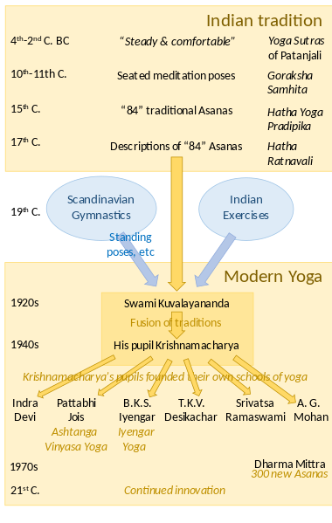

**The text below goes with the history of yoga & asana.**

In the beginning yoga (asana’s, kria’s, chanting and cleansing the body through breathing exercises for concentration purposes) was only a preparation for meditation and used for stimulating the process to go within. Asana was a preparation to be able to sit longer in the “sthira sukham asanam” (steady and comfortable pose). Yoga back than was only a spiritual and meditative practise. Yoga was learned from yogi to yogi, from guru to disciple. Almost all yogis were man.

Deep inside every one of us, lies a deep reservoir of tranquillity***.***

The Yoga asana practice is a technique is to create a clean and pure body so the fluctuations of the mind starting to slow down

In the west, yoga mostly is known as a series of postures that offer physical benefits. This view confines the yoga experience to only what occurs on the mat. That is just the thinnest slice of the entirety of yoga.

Yoga is one of the oldest spiritual traditions in the world. In the Indus civilization you find a lot of evidence.

The goal of all yoga’s system is the realisation of the innermost self (Atman = Individual Self) with the Universal Self (Brahman or Purusha). To come back to oneself, rediscover yourself, to come to love yourself and to understand that we are not separate from the totality. We are whole, nested within.

Purpose and goal of yogic practices and ayurvedic balanced lifestyle is to have all prana available in any given moment to direct it up to sahasrara, the up most chakra.

There came a lot of yogi’s to the East, with hopes for spiritual wealth, but with little impact.

Sri Tirumalai Krishnamacharya has had immense effort on the way yoga is practiced in the US, as four of his main students had incredible wide influence on introducing yoga to the culture. He educated Indra Devi (1899), BKS Iyengar (1913), Sri K. Pattabhi Jois (1915) and TKV Desikachar (1938).

Sri Tirumalai Krishnamacharya took postures out of obscurity , researched and refined them to perfection and brought them to the public stage.

BKS Iyengar played the most significant role of bringing yoga in the west. He was ill from birth, and this ´gift´ of unfortunate ill health, took him to do yoga. He wrote many books (of which at least one of them is on your list) about the performance of asana, pranayama and spiritual practise.

The understanding of yoga comes through a continuous practice.

Then we start experiencing the power and beauty of the yoga practices and Yoga becomes integrated in our life as a way of living.

We can influence so much with yoga in the body. It is a general health preserving: cheap and you can do it yourself, it is a great wellness tool.

If we can master our mind, entire worlds open up to us. Yoga provides us that promise.

Nice article to read: <https://oneflowyoga.com/blog/the-meaning-of-yoga>

**Ohm Aum Omkar**

Omkar is the name of the Symbol. Aum or Ohm is the sound

It is said if you practice chanting the sound of AUM or Ohm for 20 minutes, it will reset your nerve system.

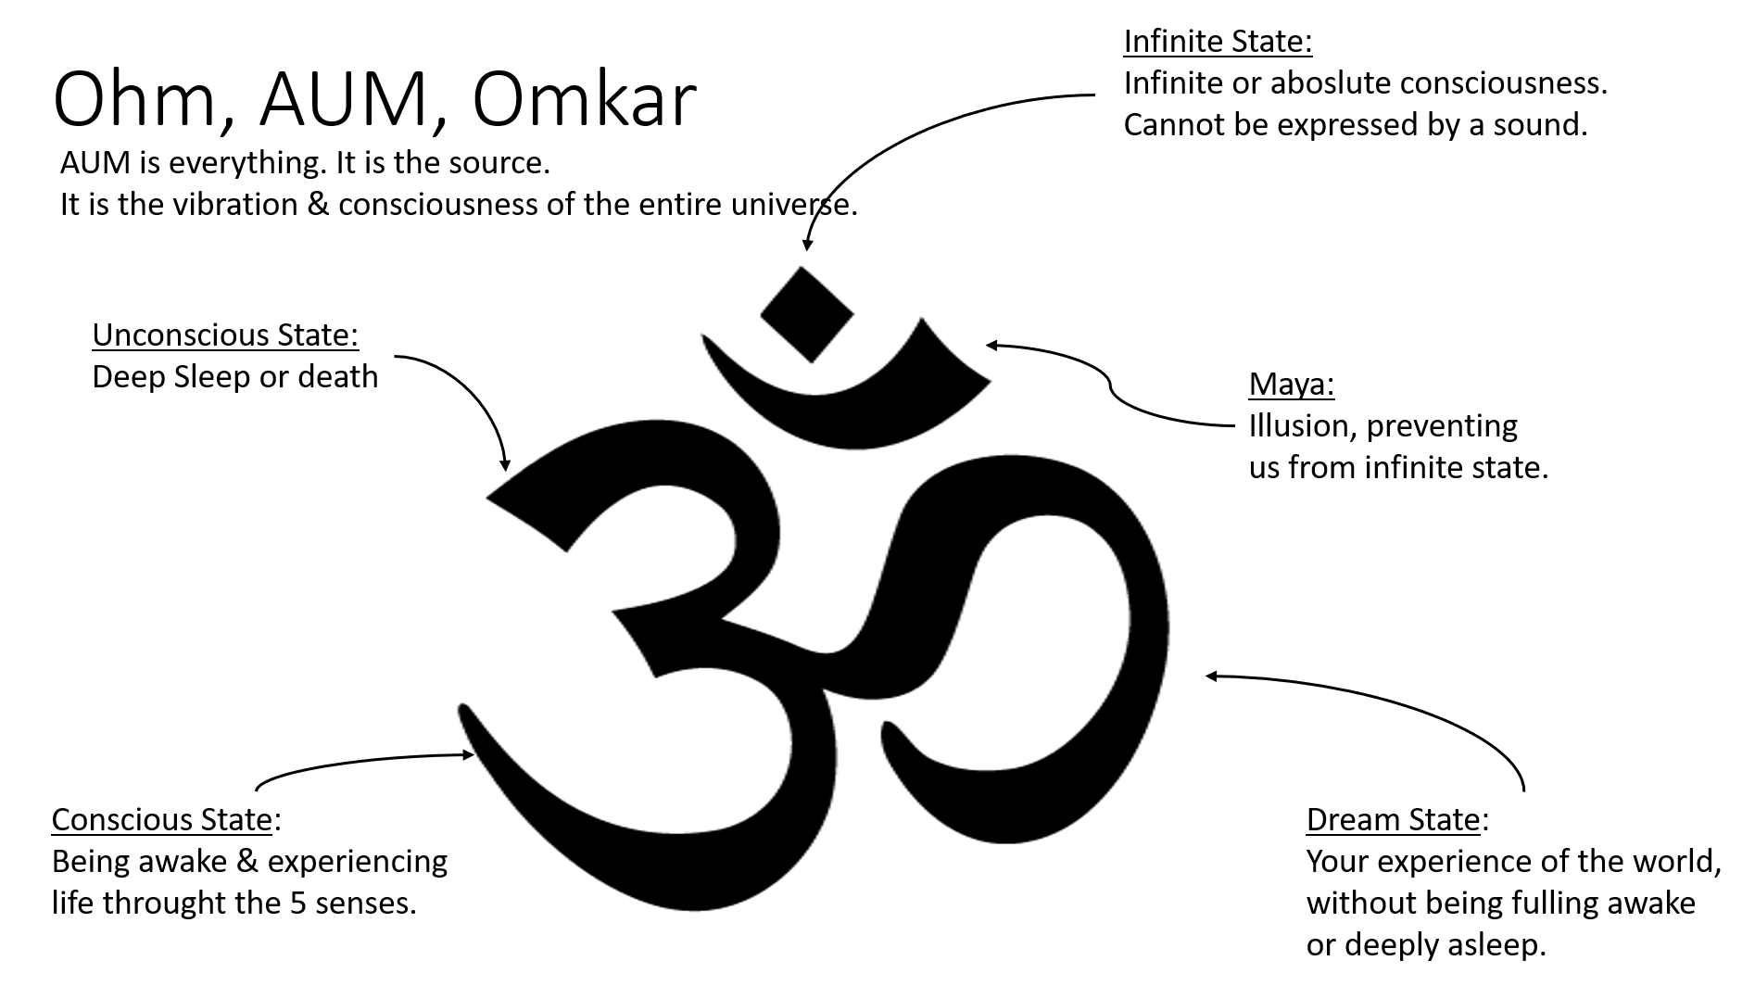

Day 2:

What does a yoga class consist of…?

***The Yoga Sutras of Patanjali.***

On day one, we learned about the history of yoga and the brief history of asana.

It is very interesting if someone wants to dive deeper into the types of yoga that have emerged from Krishnamacharya and his disciples.

Before Indra Devi, all yogi´s were male and it was one-to-one teaching.

A Sutra is a verse, a thread, containing deep wisdom.

Sutras are combinations of words thread together. There are 200 Sutras.

Pantanjali is a mystic with a scientific mind.

The Yoga Sutras is exploring the mind, with very down to earth descriptions and explanations of the mind, in a systematic and scientific way.

He created a wider understanding of the benefits of Yoga for contemporary people.

Here you also find the 8 fold path of Yoga: Ashtanga Yoga or Raja Yoga.

**Sutra 1.1 Atha Yoga-nushasanam: now, the teachings of yoga. *Or simply put: Yoga is now***

Atha=Now: at this promising moment, for which you have prepared.  
Yoga: union, integration, disciplined activity, connection, participation   
Anu = to follow a tradition, a path  
Shasanam: to hand over and apply the teachings, that comes together with discipline. Also: exposition, and “to instruct”.

**Sutra 1.2 Yoga Chitta Vrtti Nirodaha:**

Yoga stills the fluctuations of the mind (the mind-stuff).   
The mind isa a function, an activity. The mind is an activity, it all includes thoughts, feelings, it is a a library of memories and experiences.

Nirodahah: to control, to calm, to understand, to give direction.

Yoga is cessation of the mind. It is to rise above the mind, not stopping the mind. ´Something´ is recognizing the ever changing mind. That something is called Atman, awareness,Brahman, Purusha.

Resting in your own being while watching the Body/Mind functioning.

This is the path of Yoga.

**The Mind consists of 3 layers/levels**

1. Manas; senses from primal instinct. The capacity to remember, receiving impressions throught the senses, inner voices (am I doing this correct?). It keeps you from danger, avoid pain and rules the basics as eating, drinking, sleeping. The external senses
2. Ahamkara: self image, that is informed by your surroundings (introvert). Ego, I-consciousness.
3. Buddhi: intelligence, the awake part of your mind/spirit, your inner wisdom.

**Sutra 1.3**

Then pure awareness abides in its very nature.

You are not the body, you are not the mind.

You are the witness, the watcher

**Sutra 1.4**

Otherwise awareness takes itself to be the patterns of consciousness or differently put:

In other states there is identification with the modifications of the mind:

I am a yoga teacher, I am a woman, I am angry etc

The Vrittis: the 5 fluctuations/the 5 modifications of the mind:

1. Knowledge (right), When you meditate , the right center starts functioning. A sage is someone who moves to the direction of which what is good.
2. Wrong Knowledge (assumption): take drugs, alcohol, intoxicants, the whole world becomes different
3. Imagination (used in right or wrong way):

Right Imagination creates paintings, music, dance.

Wrong imagination: hopes, dreams, illusion, psychosis

1. Sleep : The mind becomes totally unconscious
2. Memory (used or misused)

Remembering is not reliable.

Imagination comes in, you drop what is ugly and painful.

You often remember things that support the ego.

Right memory: being really truthful/honest to with oneself.

That clarity comes from and leads to meditation

The question is: how to come to a state of No Mind, so that the mind is not mastering you, but you are mastering the mind.

***The 4 Pathways of Yoga:***

1. Bhakti Yoga: Yoga of devotion, devotion to a life of purity. It is about love and surrender to the Divine in everything (for example chanting mantras)
2. Karma Yoga:Yoga of Selfless action and service. Every moment to moment action is done in full awareness, bringing your totality ineach action (for example doing a selfless service in a community, being a Karma Yogi)
3. Jnana Yoga: Yoga of intellect, using logic, reading scriptures, contemplate to inquire the Innner Self and our True Nature (for example reading the Yoga Sutras and comtemplate about it)
4. Raja Yoga (Asthanga Yoga): Yoga of Meditation: the 8 fold Path:Yama, Niyama, Asana, Pranayama, Prathyahara, Dharana, Dhyana, Samadhi
5. (we dive into this later in the training).